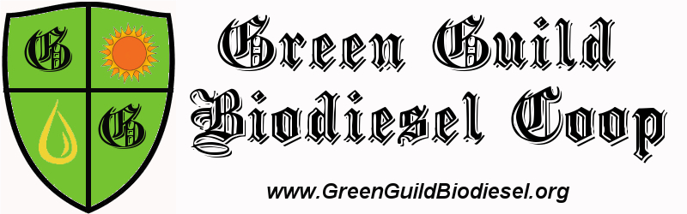

FOR IMMEDIATE RELEASE
Tuesday February 26th

Contact: Adam Schwartz
Co-founder, Green Guild Biodiesel Cooperative
adam@greenguildbiodiesel.org
301-275-2362 (cell)

Community Interest Meeting and Presentation

The Green Guild Biodiesel Cooperative, a startup nonprofit based in the DC metro area, will be holding a community interest meeting and presentation at the Center for Educational Partnership in Riverdale, MD on Wednesday March 12th at 6pm.

The Green Guild was started by two recent University of Maryland graduates in partnership with Biodiesel University and the Dingman Center for Entrepreneurship. They will be presenting plans for the creation of a cooperative business that produces and distributes biodiesel fuel from waste vegetable oil to communities in the DC area. The presentation is intended for local community leaders, those among the existing biodiesel community and prospective members. You will have a chance to tour our retrofitted school bus Biotanker and ask questions of the coordinators. Green Guild is seeking founding members as well as those interested in volunteering on a steering committee to help get this project off the ground as soon as May 2008. Come learn about this exciting venture and find out how you can get involved.

Mission Statement:
The Green Guild Biodiesel Cooperative is a member-based, non-profit, social entrepreneurship venture in the business of producing and distributing quality biodiesel fuel to the Washington DC metro area. We aim to build alternatives to economic structures based on scarcity by providing environmentally sustainable and equitable energy that empowers our community to reduce its dependence on foreign oil, mitigate its impact on the climate and environment, and strengthen the local economy. We will use biodiesel as a teaching tool to educate consumers, youth and the community about climate change and the energy crisis.
Please come learn more!
Wednesday March 12th @ 6pm
Center for Educational Partnership (in the Community Room #0131)
6200 Sheridan St, Riverdale, MD 20737

If you would like us to present to your group, or to set up a meeting or possible partnership then let us know! Please Contact Adam Schwartz with any questions or visit www.greenguildbiodiesel.org

-end-

